**Assignments 1**

**Tutorial 1 – Akash R (MCA –A)**

* **Exchanging the values of two variables**

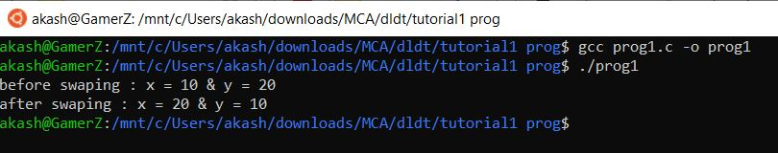

* **Counting**

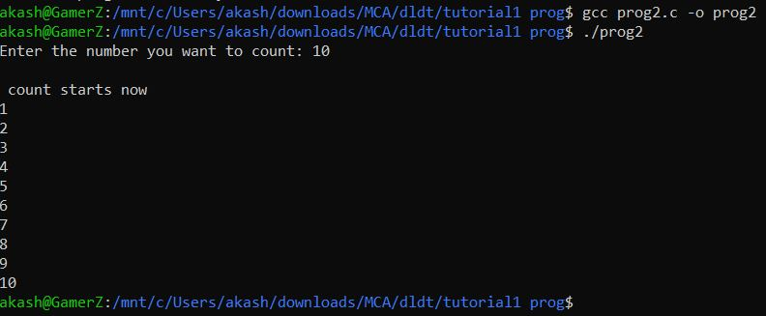

* **Summation of a set of numbers**

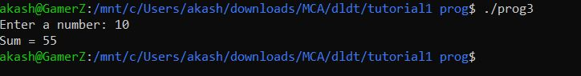

* **Factorial computation**

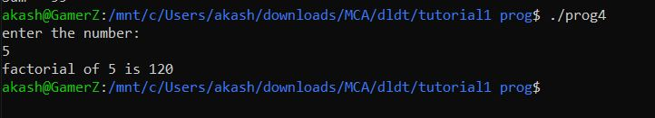

* **Generation of the Fibonacci**

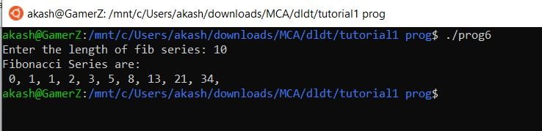

* **Reversing the digits of an integer**

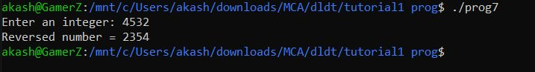

* **Sine Function computation**

